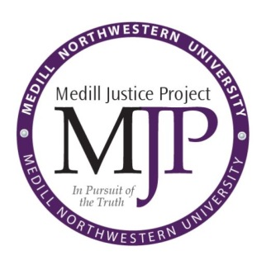
Apply to the fall quarter Medill Justice Project investigative journalism class

• Two-unit course open to juniors and seniors
• One of the limited opportunities for students to get involved with MJP
• The only university class in the country where students investigate a potentially wrongful conviction and publish their findings
• Historically, students have uncovered information that has played a role in the release of prisoners and affected public policy decisions
• Learn the essentials of investigative reporting, including where to obtain public records, interviewing techniques and developing sources
• Ten seats available, by application only
• Applications are due Sunday, May 13 at 5 p.m.

For more information or questions, please contact Allisha Azlan or Rachel Fobar, associates at The Medill Justice Project, at allisha.azlan@northwestern.edu or rachel.fobar@northwestern.edu or visit www.medilljusticeproject.org. To access the application online, visit www.medilljusticeproject.org/apply.

APPLICATION FOR INVESTIGATIVE JOURNALISM COURSE

As a two-unit course, Investigative Journalism gives students hands-on experience surrounding the criminal justice system through investigation, research and reporting on potentially wrongful convictions.

Please respond to the following questions and email your application to Allisha Azlan and Rachel Fobar at allisha.azlan@northwestern.edu and rachel.fobar@northwestern.edu.

(a.) | Explain your reasons for wanting to take this class.
(b.) | Describe your commitments for fall quarter, including all other classes you will be taking as well as the specific extent of your extracurricular activities and work obligations. If you are not sure about every class you plan to take, provide your total anticipated class load for fall quarter and list the classes you expect to take.
(c.) | Indicate your major(s), if applicable, and when you expect to fulfill all of your degree requirements.
(d.) | Provide the name and contact information of one reference who can best speak to your research, reporting and writing abilities.
(e.) | Provide your Northwestern I.D. for registration purposes.
(f.) | Share what else you would like us to know about you.
The deadline for submitting applications is Sunday, May 13 at 5 p.m. Applicants will be notified of their application status prior to registration for fall quarter classes.

Additional information or clarification may be required upon request, so please provide an email address that you regularly check. We will respond by email to all students who apply.

