Resources Text Communication Sciences & Disorders

Northwestern University provides a wealth of physical and intellectual resources including a network of 21research centers and institutes, investigators with appointments in multiple departments, and several interdisciplinary programs including the Northwestern Institute for Neuroscience, Language and Cognition, Cognitive Science, Cognitive Neuroscience, the Brain Mapping Group, Language and Music Systems in the Northwestern Institute on Complex Systems, the Institute for Developmental Sciences and Innovations, and the Training Program in Neurodevelopmental Disabilities. Facilities in the Communication Sciences and Disorders Department and related departments at Northwestern University enable faculty investigators to conduct cutting edge research in language disorders, speech-language pathology and audiology, the cognitive neuroscience of communication, and related fields. The translational research goals of faculty are facilitated by three major onsite clinics administered by the department.

The Roxelyn and Richard Pepper Department of Communication Sciences and Disorders
The Roxelyn and Richard Pepper Department of Communication Sciences and Disorders (CSD) is ranked 2nd best speech pathology program in the widely-cited US News and World Report Rankings. It occupies two-thirds of the Frances Searle Building, with 80,000 square feet of space, as well as the Northwestern University Center for Audiology, Speech, Language, and Learning (NUCASLL), a state-of-the-art clinical facility located across from the Frances Searle Building. The department includes space for 1) teaching (classrooms and laboratories), 2) clinical education/clinical services (diagnostic and treatment rooms), 3) research (laboratories designed exclusively for research), and 4) offices and administration. There are 85 well-equipped research laboratory and laboratory support rooms, encompassing over 20,000 square feet of floor space for use by CSD faculty researchers, their collaborators, and students. Facilities in the CSD Department and related departments at Northwestern University enable faculty investigators to conduct cutting-edge research in speech pathology and audiology, neuroscience of cognitive-communication, and related fields.

Northwestern University Center of Audiology, Speech, Language and Learning
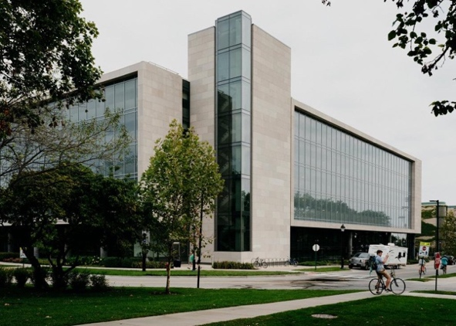
The Northwestern University Center for Audiology, Speech, Language, and Learning (NUCASLL), the department’s outpatient clinic, is located across the street from the Frances Searle Building and CSD Department. NUCASLL facilities include 34 clinic diagnostic and treatment rooms, two observation rooms, and two lecture rooms for a total 21,500 square feet of space. Members of the clinical faculty are experts in areas of practice ranging from voice disorders, motor speech disorders, swallowing disorders, aphasia, hearing loss, learning disabilities, and neurodegenerative disorders. Clinicians, physicians, and students work together in this non-profit clinic that is at a unique intersection of providing the highest quality of diagnostic and treatment procedures to clients of diverse cognitive-communication, speech, language, voice and swallowing disorders, and serves to train future clinicians, while also participating in innovative clinical and translational research. The clinical faculty regularly collaborates with the CSD department laboratories in research aimed at understanding the pathophysiology of communication disorders and providing scientifically validated evidence to inform clinical practice. Resources within this facility include one Pentax stroboscope tower, a flexible laryngoscope, and two rigid laryngoscopes. Within NUCASLL, Dr. Martin-Harris has a 16x8ft clinic room dedicated to her research and clinical work. In this room, there is access to wearable sensors and tablets as well as the current gold-standard equipment used during the validation studies including, respiratory inductance plethysmography (Inductotrace and BIOPAC) and electromyography.

School of Communication Information Technology (SoCIT)
Every faculty and staff member in the School of Communication is provided with a desktop or laptop computer every 3-4 years. All members of the university community are provided with access to secure 802.11ac wireless network access, as well as wired Ethernet ports in every building. Our facilities have default gigabit (1Gbps) synchronous Internet connectivity at every wired port, with arrangements for synchronous 10Gbps network access available. Northwestern’s two campuses in Evanston and Chicago peer with multiple providers and research. Networks such as Internet 2, Abilene, and Starlight.
An infrastructure based on Unix/Linux and Windows servers is in place which provides:
- DNS, DHCP, Active Directory, and other basic network services
- Single sign-on (SSO)
- Multi-factor authentication
- Shared network file systems
- Encrypted cloud backup of university-owned endpoints
- Enterprise endpoint management and audit tools
- Email, calendaring, and other collaboration systems
- Enterprise-class VoIP
- Videoconferencing
- Secure public-based cloud storage
- Highly secure and redundant research storage on the terabyte scale
For computationally intensive tasks, we share a computing cluster with 4008 64-bit cores running at 2.26GHZ each and 48GB of memory per node. NU’s computing cluster is currently listed in the Top500 List of supercomputer sites.
Additionally, Northwestern has business agreements in place with public cloud providers Amazon Web Services, Microsoft Azure, and Google Cloud. Special tenancies in AWS and Azure are available for sensitive, contractually restricted, or PHI data.
Videoconferencing
Faculty have shared access to two fully-equipped four-camera video conference classrooms and a portable high-definition videoconference unit that is available for use in any office or classroom.
Studio Facilities
Faculty have shared access to a fully equipped television studio, a fully equipped film studio, an animation lab, and editing suites.

Northwestern University Information Technology (NUIT)
The Research Data Storage Service through NUIT is the University’s central storage platform made available to Northwestern University. The SCSC has a private, protected server to manage the data gathered from research studies. All stored data are de-identified, linked to an Institutional Review Board protocol and password protected. Each subfolder on the server is individually accessible only with NUIT security clearance granted solely by PIs. The network is able to house large data sets including high-definition video and audio data and high-definition videofluoroscopic diagnostic studies.
Communication Research Registry (CRR)
Colleagues in CSD and Linguistics developed and maintain a P30-funded research registry (Core 1 Subject Research Registry PI: Losh) for patients with communication disorders. The registry includes a secure HIPAA-compliant, web-based portal into which patient medical history, clinical diagnostic, speech, language, and cognitive assessment measures, clinician and patient treatment goals, types and plans of care, and health-, and quality of life-related outcomes are entered. The CRR facilitates patient participation in research and collaboration among researchers across disciplines, injects consistency, standardization, and transparency into the data collection process, and facilitates turnkey implementation for single and multi-site clinical trials. Furthermore, the comprehensive reporting capabilities made possible by the dynamic query builder provide limitless options for clinical trial data analysis on a large scale.
The Data Registry includes approximately 800 HIPAA compliant records of patients who have been seen for a wide range of communicative and neurodevelopmental conditions, including autism spectrum disorder, intellectual disability, and neurodegenerative disorders. The Registry includes standard coding for patient demographics, biological variables, medical history, diagnosis, and co-morbidities (ICD9 and 10). Using the dynamic query builder, clinicians (SLPs), clinical site managers administrators (Site PIs), master administrators (PI team), and statisticians can build custom queries by selecting any number of fields defined within the Patient Medical History and Assessment and Treatment Data as search criteria. The user will have the option to return a partial or exact match on any of the selected search criteria. Qualifying data will be returned within a table and made available for export in CSV format. Created queries can be saved in a Query Library and reused for subsequent data analysis efforts. Depending upon the user’s access level, they will have the option to perform queries on patient data they have entered, patient data associated with the site, and the patient database in its entirety.
Northwestern University Library
Established in 1856, the Northwestern Library System has 372,690 square feet of usable space across five buildings in Evanston and Chicago campuses. The library is equipped with 17,726 square feet of high-density shelving, 379 high-end computer workstations, oversize plasma screens and smartboards, and 12 staffed service points that serve the students and faculty of Northwestern University. The library has a collection of approximately 7.9 million print and electronic volumes, including 107,446 print journals and 173,089 electronic journals and other serial publications, 100,560 films and videos, 125,052 audio files, and 341 terabytes of unique digital content. Online resources include the full catalogs as well as major biomedical databases (e.g., MEDLINE, PsychINFO, Embase, CINAHL). The library offers 15 specialized collections and centers that primarily serve the schools or departments they are associated with and are open to all Northwestern faculty and students. The CSD Department has a dedicated subject librarian within the main university library with expertise in health sciences. Service-oriented faculty and staff assist in scholarly research activities, including copyright, digital humanities, and data management and offer 1:1 research consultation to address specific needs.
Northwestern University - Chicago Campus

Northwestern Memorial Hospital
Northwestern Memorial Hospital is an 885-bed academic medical center located in downtown Chicago. The hospital has been listed by the U.S. News & World Report as the number one hospital in the state of Illinois and listed as a top 10 hospital in the nation. With 11 nationally ranked specialties, including pulmonary, neurology, otolaryngology, and gastroenterology, Northwestern Memorial provides a fertile environment for the development and execution of interdisciplinary clinical-research investigations.
Northwestern Memorial Hospital Speech, Language, and Swallowing Services
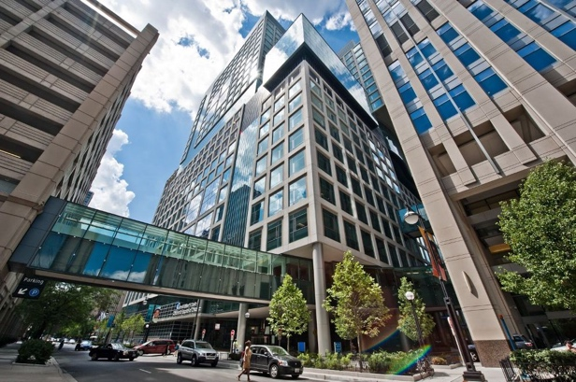
Within Northwestern Memorial Hospital, there is a 1,195 square foot space on the seventeenth floor of the hospital’s Galter Pavilion dedicated for outpatient speech, language, and swallowing services. This area includes five therapy rooms, secretarial space, a waiting area, a file room, and a shared fluoroscopy suite. SCSC has a dedicated research space within the clinic for data collection purposes. The center houses state of the art equipment that enables clinicians and researchers to make refined measurements of aerodigestive function. This includes the evaluation of oropharyngeal swallow physiology through the use of high-resolution, high-line videofluoroscopic imaging and recording (TIMS 2000 SP DICOM System, Foresight Imaging, LLC), flexible and rigid fiberoptic endoscopy, respiratory physiology through the use of respiratory inductance plethysmography and pneumotachography, and muscle contraction through the use of electromyography and high-resolution manometry. This department is staffed by six licensed and certified speech-language pathologists who conduct an average of 1,200 modified barium swallow studies a year. The NU clinicians are actively engaged in research protocols critical for the translation of laboratory work into clinical practice. The clinicians have been trained in standardized and reproducible approaches and interpretation of speech, voice and swallowing data collection within routine scope of care.

Feinberg School of Medicine
Northwestern University’s Medical School, Feinberg School of Medicine (FSM), is composed of an interconnected six-building complex on the Chicago campus located adjacent to the buildings of Northwestern Medicine. During the past ten years, Northwestern has seen a significant expansion in faculty committed to biomedical research and education, and concomitant growth in research resources, grants and university financial commitments. FSM has a robust infrastructure for support of research. Directly and through its departments and centers, FSM supports 26 centralized core facilities that provide instruments and services not commercially available, are beyond the means of individual investigators, or which can be provided most efficiently on-site. In total, over 30 Centers and Institutes support basic science and clinical research at FSM. Many of these are NIH-funded, including the Robert H. Lurie Comprehensive Cancer Center, the Cognitive Neurology and Alzheimer’s Disease Center, the Multidisciplinary Clinical Research Center in Rheumatology, and the Skin Diseases Research Center.
Abbott Hall
Abbott Hall, located near Feinberg School of Medicine (FSM) Facilities and Northwestern Memorial Hospital (NMH) in downtown Chicago, is the School of Communication’s downtown Chicago hub. The intention of having a hub at this location is to assist in pioneering research and interdisciplinary collaborations. Abbott Hall houses the Graduate programs in Health Communication and the Center for Communication and Health. The CSD Department has a designated clinic space in Abbott Hall which includes a wet lab and data collection room.
The Simpson Querry Institute for Bioelectronics (SQI)
The Simspon Querry Institute (SQI) for Bioelectronic Systems represents the breakthrough technologies that bridge the gap between biological systems and existing technology. SQI and has recently expanded by 5400 square feet with office and research space in the Louis A. Simspon and Kimberly K. Querrey Biomedical Research Center in Chicago. Their dedicated research space includes a large conference room, a multifunctional collaborations suite, a maker’s lab, Faraday cage, and a hospital simulation room, which allows researchers to test how their devices function in a clinic setting. The telehealth kits that will be used in this study will be manufactured by Sonica Health, a non-profit digital medical company and a spinout of Northwestern University’s Querrey Simpson Institute for Bioelectronics.
Northwestern University Clinical and Translation Sciences Institute
Northwestern University Clinical and Translation Sciences Institute (NUCATS) is a member of the Clinical and Translational Science Award Consortium, part of the National Center for Advancing Translational Sciences. Funded through the National Institute of Health Clinical and Translational Science Award, NUCATS has served over 3,000 investigators. The institute houses individuals working on similar areas of the clinical and translational pipeline within five centers: 1) Center for Translational Innovation, 2) Center for Clinical Research, 3) Center for Community Health, 4) Center for Data Science and Informatics, and the 5) Center for Education and Career Development. Operationally focused programs unite centers and provide a common thread of support that is used among all centers: Biostatistics, Epidemiology, and Research Design, Applied Research Informatics Group, Pilot Translational and Clinical Studies Program, and Team Science Program. In addition to the central support available through the central program lines are the extraneous services that NUCATS provides including data science and informatics services, research support, community and stakeholder engagement, research networking systems, core resources, and drug, device and diagnostic development. Dr. Martin-Harris, her study team and collaborators will leverage resources and services to optimize learning and research productivity.
Biostatistics Collaboration Center
Since being established in 2004, the Biostatistics Collaboration Center (BCC) has contributed their expertise in biostatistical science, programming and data management to the high-quality, innovative medical research done by Northwestern investigators that ultimately results in funded grants, peer-reviewed publications, and presentations at professional meetings. The center’s scope includes Northwestern University Feinberg School of Medicine and is academically housed in the Department of Preventive Medicine. The BCC’s faculty and staff work with investigators in all aspects of their research projects, from concept and study design to data acquisition, data analysis, and final scientific reporting. Master’s-level statistical analysts and programmers work with the faculty biostatisticians to provide programming and data management support ranging from one-time consultations to long-term collaborations. They also offer workshops and seminars on research and statistical methods. BCC statisticians have relationships with major units, including Northwestern University Clinical and Translational Sciences Institute (NUCATS), the Institute for Public Health and Medicine, the Robert H. Lurie Comprehensive Cancer Center, the Cognitive Neurology and Alzheimer’s Disease Center, the Multidisciplinary Clinical Research Center in Rheumatology, as well as individual Departments and Divisions. Dr. Jungwha Lee, Co-investigator, is part of the BCC and will leverage resources and services that are offered by BCC for data analysis and dissemination.
Center for Data Science and Informatics
The mission of the Center for Data Science Informatics (CDSI) is to advance the applications of data science to improve biomedical research and healthcare. The CDSI stress the importance of maintaining compliance with security policies and procedures to protect data. They provide consultation on data security plans used in clinical research, including updated policy and procedure documents, guidelines for file storage, and hardware and software standards. The CDSI provides software, REDCap, that allows investigators to manage their data securely. The REDCap database is where all identifiable data is stored for research studies conducted in the SCSC lab. The CDSI also provides 19 other software tools to augment and accelerate the translational research project.
Enterprise Data Warehouse (EDW)
NUCATS also supports a comprehensive repository of all clinical and research data sources on campus. Currently, it stores observations on more

